**NETWORKING 101**

1. **The Internet and IoT**

IoT is a giant network of devices via embedded technologies.

75+ Billion devices will be connected by 2025

307 million US Internet users / 64% of global population

Broadband delivers high-speed internet to connect devices

The Cloud stores data and delivers information online. 1 ZB (zeta) = 1 Trillion GB

RMR, or *Recurring Monthly Revenue*, refers to ongoing services that customers pay for on a monthly basis, such as security (ie cameras, monitoring), access and home control (ie lights, temperature, sprinkler), streaming entertainment, and PERS (personal emergency response system). All services are amalgamated with Internet Service Provider.

1. **What is a Network?**

A *Network* is a combination of cables, hardware devices and software.

A *Local Area Network (LAN)* is the most common network type, used in a single physical location, such as a home, and consists of a router, modem, computer and possibly a switch, printer or server. Users in this network can share all resources.

A *Wide Area Network (WAN)* is a geographically dispersed network of connected LANs. While a router connects a LAN to other networks, the Internet is a WAN comprised of many LANs connected to many different routers. Routers can communicate with any modem provided by the ISP, and the modem communicates with the ISP and the ISP provides the link to the internet.

Other Network Types: PAN - WLAN - CAN - MAN - SAN - VPN - EPN - POLAN

Network connectivity is a process of hooking up a computer to a switch that passes signals to/from the rourter, which talks to the modem and directs traffic between the network devices in the house on the LAN, and to the Internet. Two-way communication between the LAN and WAN allows for remote control of LAN devices.

Ethernet speed over twisted-pair is designated by #baseT. The # refers to the speed in Mbit/s, base indicates baseband transmission is being used, and the T indicates twisted-pair cable.

|  |  |  |  |
| --- | --- | --- | --- |
| Slow | Fast | Faster | Fastest |
| 10Base-T | 100Base-T | 1000Base-T | 10GBase-T |
| 10MB/s | 100MB/s | 1000MB/s = 1GB/s | 10GB/s |

Twisted-pair cable is defined by category rating, which identifies the bandwidth:

CAT 5/5e supports transmission frequencies of 100MHz + 1GB/s

CAT 6 supports transmission frequencies of 250MHz + 10GB/s

CAT 7 supports transmission frequencies of 600MHz + 40GB/s

*Broadband* refers to its ability to transport multiple signals and traffic types simultaneously. The medium used is coax, optical fiber, twisted pair and wireless.

Internet Connection Options:

*Cable modem* using coax cable to access cable TV channels.

DSL (Digital Subscriber Line) uses existing telephone lines to connect to Internet.

*Digital Services* are used for business applications, have guranteed speeds, and are expensive. Common services include ISDN, Fractional T1/PRI, T1, and T3.

*Fiber optic cable* provides extremely fast access and installed by ISP.

*Wireless broadband (3G/5G)* is delivered through cellular networks, as hot spots.

A *Satellite dish* can connect to the Internet.

A *Wireless Internet Service Provider* uses a special antenna that contains an active receiver.

*Dial-up* is not used much because it is slow and not directly connected to Internet.

Network Devices:

1. Modem exchanges communications between the ISP and the LAN.
2. Router directs traffic between LAN and WAN networks, provides addressing services for LAN devices through Dynamic Host Configuration Protocol (DHCP), and allows all devices on a LAN to share a single Internet connection.
3. Switch expands the number of connections and manages traffic on a LAN.
4. WAP provides wireless access to a network, like a hotspot, using RF signals.
5. NAS (Network Attached Storage) stores large amounts of data and can be accessed
6. Firewall protects against unwanted access to a LAN.

*TCP and IP provide a way for devices on a network to communicate with each other.

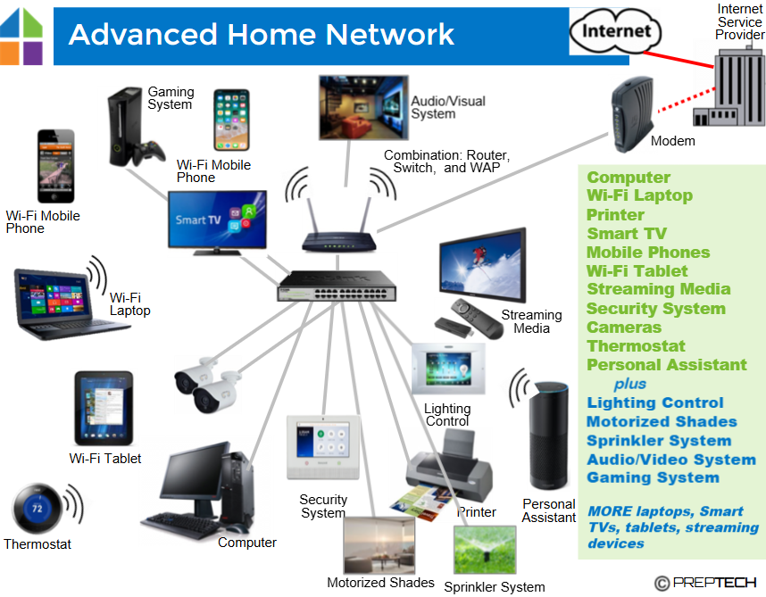

1. **Protocols and Naming**

A *Protocol* is the common “language” of a network, and all devices on the network must utilize the same language and be configured with the appropriate protocol settings to effectively operate.

A *Domain Name Service* (DNS) refers to the user-friendly “nickname” for a public IP address on the internet, which is made up of numbers.

##.##.##.##.##An IP (Internet Protocol) address is a unique number that is assigned by an ISP/automatically by DHCP. An IP address can be assigned by manually programming the individual network device directly, which is known as a static/fixed IP address.

IP numbers are extended and assigned to connected devices. IPs identify all devices connected to a network, are specific to location.

##:AB:##:##:##:A# Every network device is assigned a unique MAC (Media Access Control) address at the time of production.

Ethernet is the set of rules, that makes a network “work”. TCP (Transmission Communication Protocol) defines the rules for communication over the network. IP is the language used on the network. Most networks today use both Ethernet and TCP/IP.

DHCP IP Address Assignment Process:

Network device turns on, requests an IP address from router using DHCP

Router responds, providing a specific address

Network device informs router of IP address acceptance

Router assigns address and netwok device is connected.

*Every network has a unique public IP address =>

Every device on each network has a private IP address (assigned by Router) =>

NAT Network Address Translation provides security by hiding internal IP addresses from the internet, and enables use of more internal IP addresses, and allows multiple devices to use a single internet connection.

*Wireless networking* is defined by the IEEE 8021.11 standard (1997), whereby protocol specifications based on frequency, bandwidth, modulation, speed and range.

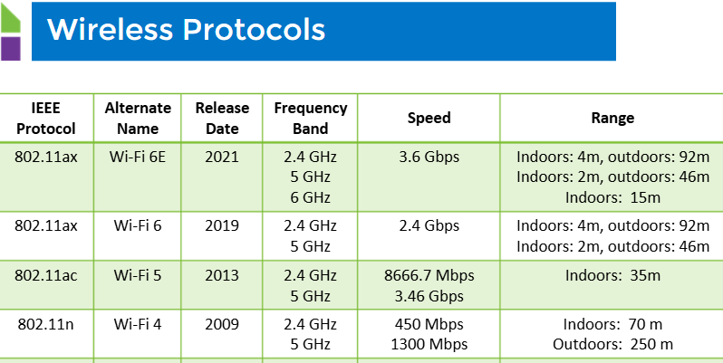

1. **IP Addressing**

TCP/IP is the common network language of the Internet. All devices will have a unique IP address to connect to the network.

IP Addresses are identified as Private (internal home network address) or Public (external Internet address).

192.168.1.101

Each number can have a value between 0 - 254.

First three numbers identify the home network address.

The last number identifies the network device.

*IPv4* stands for Internet Protocol version 4, which is running out of addresses. The next generation of IP addressing is *IPv6*.

Locate the IP Address of a Device:

Open the Command Prompt Interface and Enter:

ipconfig Displays current IP Address for the device

ping Sends signal to specific IP Address / Receives signal for confirmation

tracert Shows the path the packet takes from your PC to a specified PC

Network Software Tools can be used to diagnose issues within a network.

1. **Network Concepts**

A *Switch* is used when to handle the traffic of a network when there are many devices being used. Multiple connections are affored via *Ports*, with some having as many as 128 connections.

Network switches enhance network performance by managing the flow of data, and increase security by controlling access to devices on the network.

A Port can be a physical connection on a network that uses an RJ45 connection. Software connections are also considered ports, identifying end-points within a network. With a single network device, multiple port numbers allow different applications on a single IP address (each IP Address can have multiple software ports; port numbers range from 1 - 65,536). Specific port numbers are assigned for specific uses:

Port 25 Port 80 Port 843 Port 20

Email Web Browsing Adobe Flash File Transfer Protocol (FTP)

*Port Forwarding* allows remote access from the Internet to specific network devices (for IP cameras, home control, and remote desktop). Port Forward to a device <http://PublicIPaddress:40001> Port 40001, 40002, 40003 to IP Address

1. **Best Practices**

Following established guidelines or procedures to ensure standarization and support the desired result.

ESD, or Electrostatic Discharge, occurs when static charges build up in the human body and on clothing. ESD can damage or destroy electronics if not properly discharged.

Always ground yourself before handling electronics

Wear a protective device (ie anti-static wrist strap)

Leave components in anti-static packaging until ready to install.

Always change default factory-set username and password to prevent network intrusion and hacking.

Network Installation Steps:

1. Configure the router
2. Connect devices
3. Add the wireless network
4. Secure the network
5. Test the network

Network Security: Anti-Virus / Anti-Spyware / Software Firewall / Data Protection / Schedule Data Backups

Documentation of Network Installation:

Hardware info / Usernames, Accounts & Passwords (used for future support)